BC School Sports Banner Order Form
Submission Details: Please fill out the form and complete all required fields, scan and email to info@bcschoolsports.ca with the subject: BC School Sports Banner Order Form.

BC School Sports is offering member schools the ability to purchase both Spectator Code of Conduct Banners and /or Replacement Blue Championship Banners (pending confirmation of championship). Please complete the form on the backside if you would like to order a banner.

Available Designs/Prices:
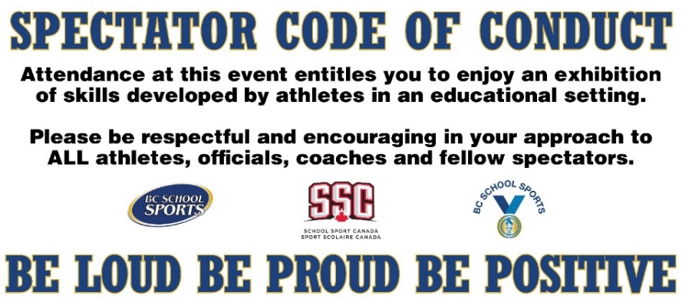

Spectator Code of Conduct Banner
Price: $100 (plus shipping)

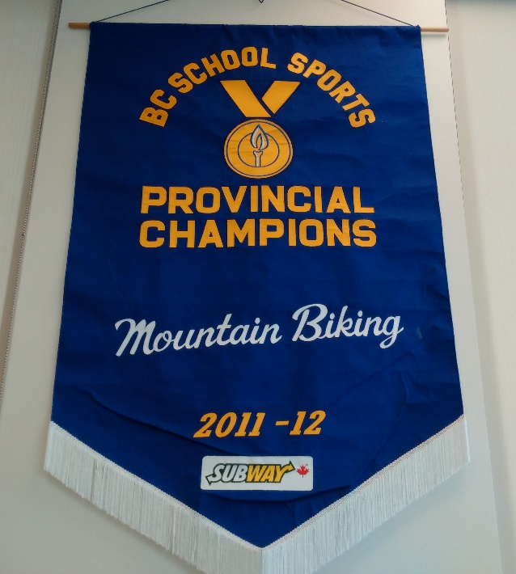

Blue Championship Banner
(Customizable sport/year/tier)
Price: $500 (plus shipping)

BC School Sports Banner Order Form
Submission Details: Please fill out the form and complete all required fields, scan and email to info@bcschoolsports.ca with the subject: BC School Sports Banner Order Form.

BC School Sports Member School Name: ____________________________________________
School Address: ________________________________________________________________
School Athletic Director Name & Email: _____________________________________________

What banner(s) you would like to purchase:
__________ X Spectator Code of Conduct - $100 (plus shipping)
__________ X Replacement Blue Championship Banner - $500 (plus shipping)

If you are ordering a Replacement Blue Championship Banner, what sport, tier and year would you like to order?
Sport(s): ______________________________________________________________________
Tier(s): ________________________________________________________________________
Year(s): _______________________________________________________________________

Total Order Cost: $_______________________

