BC School Sports AGM May 6, 2017
Travel Arrangements
Zone A, B, C, D, E
Kootenay, Okanagan, Northwest Zone, North Central District, Vancouver Island
BC School Sports will contribute $75 per school representative that attends the AGM. Delegates are encouraged to carpool and share accommodations where possible. An Expense Claim Form must be submitted by May 6, 2017.

Zone F and G
Lower Mainland (including Howe Sound), Fraser Valley Representatives from these schools are not eligible for travel assistance.

Observers
You will be responsible for covering your own travel costs.

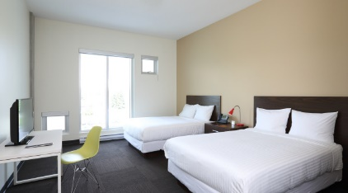
Accommodations
The Lodge @ Fortius
Fortius Sport & Health
3713 Kensington Ave,
Burnaby BC V5B 0A7

Member schools, delegates, and council members are responsible for their accommodation costs. BC School Sports can book hotel rooms on behalf of these groups at a discounted rate ($99/night + tax). All rooms booked through BCSS will be located at The Lodge @ Fortius (same location as the AGM). Your stay includes complementary Wi-fi, parking and fitness centre access. For more information about The Lodge @ Fortius, please visit.
http://www.fortiussport.com/Facilities/Pages/TheLodge.aspx

Many rooms have two double beds allowing two delegates to easily share a room. If you will be sharing a room, please specify this when making your booking request. All room booking requests must be sent to info@bcschoolsports.ca by April 21.

AGM Meals
On Saturday May 6, a hot breakfast will be provided. All other meals are the responsibility of the delegate.

BC School Sports AGM May 6, 2017

Expense Claim Form-due May 6, 2017
I certify that I have or will attend the AGM on Behalf of ________________________.
(School name)

I am the only person claiming the $75 travel credit on behalf of the above-mentioned school.
Attendee name: __________________________________________________
Cheque Mailing Address: _____________________________________________________
Postal Code: ___________________________________________________________
City/Town: ___________________________________________________________
Home Phone: ___________________________________________________________
Email: ____________________________________________________________
Make cheque
payable to: ____________________________________________________________

Please Scan and send this page to info@bcschoolsports.ca.

If this form is received by BCSS before April 21, a cheque for $75 will be available for pickup during registration at the AGM. Cheques for delegates who submit this form after April 21 will receive the cheques by mail at a later date.

